Lab5: Brandon Kowal, Bernard Owusu Sefah

BCD-to-7-Segment Decoder

Abstract

The lab has us design a circuit that takes a 4-bit input and has 7 outputs. The seven outputs can then be inputted into the 7-segment code conversion to display number 0-9.

Introduction

This Lab will have us Design basic AND, OR, and NOT gates using NAND and NOR gates. The Experiment will use the BCD-to-7-segment code conversion to see the number outputs. This will also improve our skills in WinLogiLab with designing and testing the circuit.

Methods

1.We had to construct the BCD circuit we develop in the prelab and verify it to the trace output developed by winlogiLab to make sure it was right.

2. We then connected out circuit to the digital display on the ETS-7000 and also connect a resistor to resist the current flowing to the 7-segiment display.

3. Connect the output of the 7-segiment display to the switches on the ETS-7000.

4. Power on the ETS-7000 and push the switches to change the digits on the 7-segiment display to display numbers from 0 to 9.

5. Connect the wires from the output of the 7-segiment display to the MSO and capture the results.

Results

MSO screen-capture of the 7-segiment display

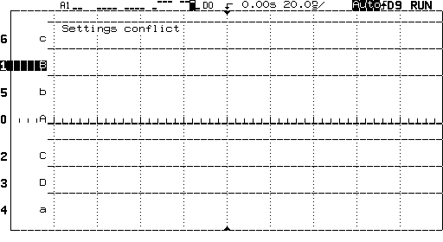

Discussion

In our lab the ETS-7000 has a built in seven-segment display so we were able to display 0-9 numbers on that display. In the task 1 we had to use the 7448 IC and the 7-segment display. This circuit required a resistor and it took a little bit longer to rearrange how the resistor should be. We were then able to display numbers 0-9 by using the switches on the ETS-7000.

Conclusion

In this lab we were able to create the BCD-to-7-segment decoder that displays numbers 0-9.

We used the 7448 IC that takes the 4-bit input and has the 7 outputs to form the number on the display.

Appendix

Lab Attendance: Bernard Owusu Sefah: Yes Brandon Kowal: Yes

Involvement in Lab: Bernard Owusu Sefah: 55 Brandon Kowal: 45

Involvement in Lab Report: Bernard Owusu Sefah: 50 Brandon Kowal: 50